Documentatie proiect SI

**2024**

**-Sistem automat de procesare de imagini pentru recunoașterea video a culorilor de la semafor-**

**Burduniuc Iulian**

**Bran Diana-Georgiana**

**Anița Iulia-Andrada**

**1.Componente Utilizate**

* *Raspberry Pi 4*

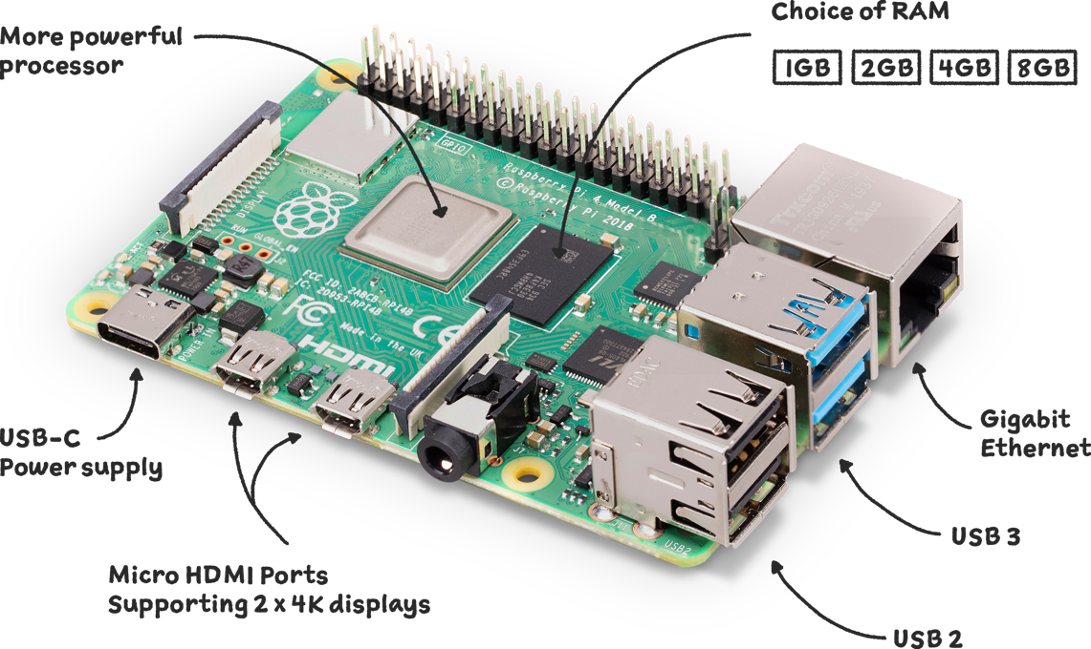

* *Modul Camera 3*

* *Tastatura*
* *Mouse*
* *Monitor*

**2.Shema Hardware**

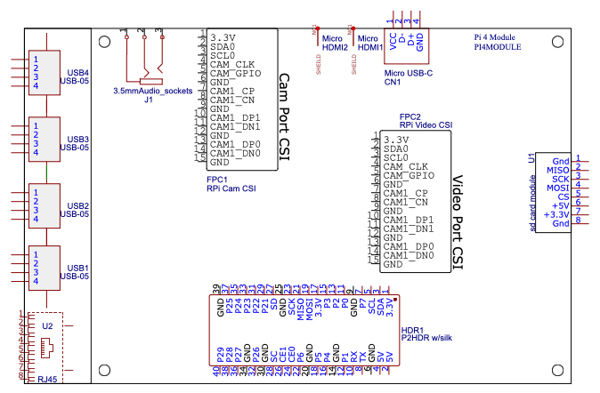

**3.Dataset**

**Sursa:** Hugging Face.**

**Link:** <https://www.kaggle.com/datasets/tuanai/traffic-signs-dataset/data>

**Descriere:**

* 6000 de imagini

* 50 clase

**4.Code**

